**COMAPANY PROFILE**

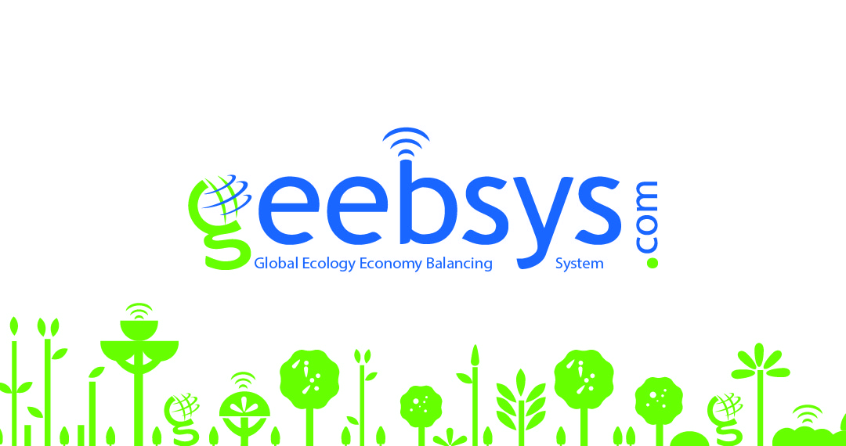

# GLOBAL ECOLOGY ECONOMY BALANCING SYSTEM

**Vision of the Visionary**

A philanthropist and an environmentalist by choice, Shri Virandar Mohan is a visionary in the true sense. Inspired by the values and social initiatives undertaken by his father late Shri Ram lal Sharma, Virander Mohan has always understood his responsibility towards society - social, environmental and economic while continuing all his ventures. An industrialist by profession and a social worker by passion, Shri Virander Mohan have always set an example by adopting various eco-friendly measures to save his immediate environment and the earth from any harm and damage. His endeavors have led him to motivate others to follow the same.

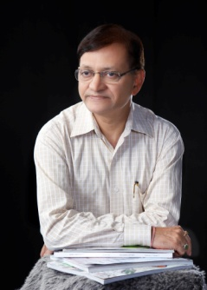

In 1995, he invested in the effluent treatment plant (ETP) i.e. industrial waste water treatment plant that was a huge initiative at the time; it not only helped in reducing soil & water pollution but also resulted in an overall development of the factory environment. It was mystery for him that people in the society only spoke of material gain often with complete disregard for the earth that they were destroying. Taking cue from this, he thought of a world where each individual would feel a need to save and preserve nature and life. So was born the Global Ecology Economy Balancing System (GEEBSYS).

Why can’t we become the change we desire to see? questions, Shri Virander Mohan. His vision is simple - to pass on a sustainable world to our future generations. In order to realize this vision, our aim needs to be to inspire, encourage and motivate everyone to come forward and join in with their genuine efforts.

Through innovation & technology, Geebsys acts as a support system where one can:

* Promote activities benefitting society-like events run by RWA & other communities
* Make your contribution by doing your bit
* Get a structured platform to report the time & energy invested for conducting ISR(Individual Social Responsibility) /CSR(Corporate Social Responsibility) activities.
* Find connections, build associations & spread awareness about your cause/mission/organization/NGO
* Help create a happy, healthy and an enriching society

**Balancing of the world – ecology & economy**

Geebsys.com is an initiative to provide a platform in order to uploading a pre-publicized event being organized offline by the RWA (Residents Welfare Association) or the community in their area along with the sponsoring companies investing from their CSR (Corporate Social Responsibility) budget or advertisement budget for **:**

# 1. Promoting activities useful to the society like :-

1. Plantation of saplings of the trees , so that there is addition to the green belt of a city .
2. Cleanliness drive in the city will be a step forward to make it beautiful .
3. Protecting street animals as they also need care.
4. By conducting awareness program will make people responsible citizen of the country .
5. By imparting free educat­­­ion to the needy children – the literacy rate of the society will go up.

# 2. Save our mother nature :

Promoting all the above activities will dilute the global warming effect and betterment of civic sense in the society .

# 3. Reward every work carried out in this direction.

When each social work posted on this platform by the people will be rewarded with green points and in turn these green points will be exchanged for material benefits by the corporate houses from their CSR budget (Corporate Social Responsibility) or from advertisement budget or by offering discount in the sale of their products .Green points can also be transferred in terms of gifts, donations etc by individuals/organisations. Then everyone will be motivated to contribute more for such activities.

In other words, CSR will promote ISR (Individual Social Responsibility)

You must have heard about the carbon credit / carbon points trading. Geebsys system is the expansion of it.

So, more the green points – the company or the corporate house have the edge in the market to procure money through IPO (Initial Public Offer in the share market) , because apart from earning company it will also be considered as society friendly company because it is trusted most. Similarly companies having more green points may attract customers to increase their sale because these green points will bring them fame

**WORKING OF WEBSITE**

1. Register yourself
2. Login into your account
3. Submit/Add Social work
4. Approver to approve the submitted social work. Value of approved work determined by associated Green Points.
5. Approved work is added to your account
6. Approved work can be:
   1. Exchanged with others (Companies etc.) in exchange for material benefits.
   2. Transferred to another user, as a gift , donation , offering.

­­

**Vision /Mission**

* To respect the identity of an individual.
* To reward people for their good deeds.
* To promote and encourage ISR (Individual Social Responsibility).
* To tap and monitor the untapped potential (time & energy) of an individual.
* To give a better world to the future generations.
* To digitalize the ecosystem activities of the mankind with sustainable development
* To help the people around the world through Geebsys platform, who are deprived of the benefits of the development of the modern civilized society/world.
* To create a business friendly digital platform for the market forces with an angle of humanity.

**WHAT’S IN IT FOR ME?**

# Organization

* Encouragement to ISR (individual social responsibility) along with the CSR (Corporate Social Responsibility).
* Promotion of social cause with credentials
* Publicity/Advertisement
* Platform to launch the product
* Development
* Green points
* Satisfaction of contribution

# Individual

* Green points
* Material Benefits
* Appreciation of doing social work
* Encouragement to promote social issues
* Development of society
* Help on all social & Environmental issues
* Feel good factor

**CONTACT US**

# Head Office:

Address : A-115/2 Wazirpur Industrial Area , New Delhi – 110052

Phone No.: – 9560111952 , +91 9811192092

Website : [www.geebsys.com/](http://www.geebsys.com/) (currently in beta version : [www.geebsys.com/beta/](http://www.geebsys.com/beta/) )

Email Address : contact@geebsys.com